TTI on Camel
Installation Guide

© 2026 Temenos Software Luxembourg SA
All rights reserved. No part of this publication may be reproduced, stored in a retrieval system, or transmitted, in any form or by any means, electronic, mechanical, photocopying, recording, or otherwise, without the prior written permission of Temenos Software Luxembourg SA.
Triple'A Plus™ is a registered trademark of the TEMENOS Group of companies. All other trademarks referenced herein are the property of their respective owners.
The Temenos product suites use a number of third-party software products that are distributed under free or other open source licence agreements. These products are the copyright of their respective owners and are governed by their own licensing terms as indicated in the applicable licence, copying, read-me and/or help files for such products. Copies of the relevant licence agreements for these products can be found in the WealthSuite Front Office - Portfolio Management - Open Source Software Licenses Reference Guide.

Table of Contents

1. Introduction 4
2. Apache Camel 4
3. TTI Camel installation steps 4
3.1 Java 4
3.2 TTI Home 4
3.3 TTI Jboss Queue configuration 4
3.4 TTI IBM MQ Queue configuration 5
3.5 TTI Camel application.properties 6
3.6 JMS vendor library 8
3.6.1 ActiveMQ 8
3.6.2 Jboss 8
3.6.3 IBM MQ 8
3.7 JMS configuration 8
3.7.1 ActiveMQ 9
3.7.2 Jboss 9
3.7.3 IBM MQ 10
3.8 Encryption 11
3.9 TAFJ MDB configuration 11
3.10 Logging 12
3.11 Starting the application 12
4. SSL Configuration 12
4.1 ActiveMQ 12
4.2 Jboss 18
4.3 IBM MQ 21
Client 21
Server 22
Extraction 22
Queue Manager Changes 23
Config changes 23
Script changes 23
Sample Files 24
5. Containerization 24

Introduction
This guide describes how to install and configure TTI Camel. The configuration described in this document is the minimum configuration required to install and run the TTI camel.
To get detailed information about the functional configuration and details please refer TTI user guide.

Apache Camel
Apache Camel is an open source integration framework that provides an efficient alternative for ESB and supports various integration patterns that allows us to define routing and mediation rules.

TTI Camel installation steps

Java
TTI Camel requires Open jdk11, so install Open jdk11 in the machine.

TTI Home
TTI Home directory where TTI application look for XSLT, TTI specific configurations files
- Create a directory in any base path
/data/temenos/TTI
- Set created path as the TEMN_TTI_HOME system environment variable
export TEMN_TTI_HOME=/data/temenos/TTI
- Copy all the xslts available in the TTI delivery package into TEMN_TTI_HOME directory
$TEMN_TTI_HOME/xslt
- Copy config folder from distribution package(/Distribution/IB/config)into TEMN_TTI_HOME directory
$TEMN_TTI_HOME/config
- tti-routing.xml controls the initial routing of the messages entering into TTI. Copy the tti-routing.xml content from distribution package(tti-camel-DEV.0.0-SNAPSHOT\config\routing\) to TEMN_TTI_HOME config path($TEMN_TTI_HOME/config/tti-routing.xml)
- Refer the TTI user guide for other configuration files available in the $TEMN_TTI_HOME/config

TTI Jboss Queue configuration

Configure queues in AppServer - jboss\standalone\configuration\standalone-utp.xml

- Jms queues for the b2f routes.

<jms-queue name="T24_JMS" entries="queue/T24_JMS java:jboss/exported/jms/queue/T24_JMS"/>
<jms-queue name="T24_IN" entries="queue/T24_IN java:jboss/exported/jms/queue/T24_IN"/>
<jms-queue name="T24_BATCH_IN" entries="queue/T24_BATCH_IN java:jboss/exported/jms/queue/T24_BATCH_IN"/>
<jms-queue name="XML_B2F" entries="queue/XML_B2F java:jboss/exported/jms/queue/XML_B2F"/>
<jms-queue name="XML_F2B" entries="queue/XML_F2B java:jboss/exported/jms/queue/XML_F2B"/>
<jms-queue name="SLOW" entries="queue/SLOW java:jboss/exported/jms/queue/SLOW"/>
<jms-queue name="XML_T24" entries="queue/XML_T24 java:jboss/exported/jms/queue/XML_T24"/>
<jms-queue name="MON" entries="queue/MON java:jboss/exported/jms/queue/MON"/>
<jms-queue name="ERROR" entries="queue/ERROR java:jboss/exported/jms/queue/ERROR"/>

- Dead letter queues for error messages.

<address-setting name="jms.queue.t24IFInboundQueue" dead-letter-address="jms.queue.ERROR" redelivery-delay="5000" max-delivery-attempts="1" message-counter-history-day-limit="10"/>
<address-setting name="jms.queue.T24_JMS" dead-letter-address="jms.queue.ERROR" redelivery-delay="5000" max-delivery-attempts="1" message-counter-history-day-limit="10"/>
<address-setting name="jms.queue.XML_T24" dead-letter-address="jms.queue.ERROR" redelivery-delay="5000" max-delivery-attempts="1" message-counter-history-day-limit="10"/>
<address-setting name="jms.queue.T24_BATCH_IN" dead-letter-address="jms.queue.ERROR" redelivery-delay="5000" max-delivery-attempts="1" message-counter-history-day-limit="10"/>
<address-setting name="jms.queue.XML_F2B" dead-letter-address="jms.queue.ERROR" redelivery-delay="5000" max-delivery-attempts="1" message-counter-history-day-limit="10"/>
- Jms Queues for F2B routes
<jms-queue name="ttiOFSMLQueue" entries="queue/ttiOFSMLQueue java:jboss/exported/jms/queue/ttiOFSMLQueue"/>

<jms-queue name="ttiOFSMLReplyQueue" entries="queue/ttiOFSMLReplyQueue java:jboss/exported/jms/queue/ttiOFSMLReplyQueue"/>

TTI IBM MQ Queue configuration

Configure queues in AppServer - \standalone\configuration\standalone-utp.xml


- Create a new resource adapter for IBM MQ “IBMMQResourceAdapter”.
- Configure new connection definition for wmq.jmsra.rar.
  - <connection-definition class-name="com.ibm.mq.connector.outbound.ManagedConnectionFactoryImpl" jndi-name="java:/ConnectionFactory" pool-name="IBMMQResAdaConDef"><config-property name="channel">CLIENT.PORT.ONE</config-property><config-property name="hostName">localhost</config-property><config-property name="password">dev2010team</config-property><config-property name="queueManager">MDO</config-property><config-property name="port">2814</config-property><config-property name="username">gwpmq</config-property></connection-definition>

  - <connection-definition class-name="com.ibm.mq.connector.outbound.ManagedConnectionFactoryImpl" jndi-name="java:/JmsXA" pool-name="IBMMQResAdaConDefJmsXA"><config-property name="channel">CLIENT.PORT.ONE</config-property><config-property name="hostName">localhost</config-property><config-property name="password">dev2010team</config-property><config-property name="queueManager">MDO</config-property><config-property name="port">2814</config-property><config-property name="username">gwpmq</config-property></connection-definition>

- Configure admin-object for all the queues.
  - <admin-object class-name="com.ibm.mq.connector.outbound.MQQueueProxy" jndi-name="java:/queue/XML_B2F" pool-name="queue/XML_B2F"><config-property name="baseQueueName">XML_B2F</config-property><config-property name="baseQueueManagerName">MDO</config-property></admin-object>
- Remove all the jms-queues. There should not be any duplicate queues in the standalone xml.
- Remove InVmConnectionFactory and activemq-ra configurations.
- Copy wmq.jmsra.rar file from MQ path C:\Program Files\IBM\MQ\java\lib\jca and paste it inside /t24/jboss/standalone/deployments folder.

TTI Camel application.properties
The application.properties file has the entire configurations specific to TTI Camel application.
- Configurations can be altered directly in the application.properties file available in the distribution package tti-camel-DEV.0.0-SNAPSHOT\config\application.properties. Each property can be override using the environment variable.
- To override application property by environment variable, configuration name has to be changed like lower case has to be changed to upper case and .(dot) replaced with _.
For example, temn.tti.jms.config.file.name will be TEMN_TTI_JMS_CONFIG_FILE_NAME
Property | Description | Default
connection | Parameter to specify the connection type. Value can be either JMS or MQ | JMS
temn.tti.jms.config.file.name | Name of the jms configuration file select from TTI camel distribution folder config/jms | jms_jndi.xml
temn.tti.jms.security.password | JMS broker connection password. Specify encrypted password inside open close brace prefix with ENC keyword | admin
temn.tti.queue.b2f.request.queue | Source queue from where TTI read the records sent from T24 IFT table | t24IFInboundQueue
temn.tti.queue.b2f.input.queue | TTI internal queue, which is used to process data between routes. From this queue message will be tagged and routed to T24_IN | T24_JMS
temn.tti.queue.b2f.single.input.queue | TTI internal queue, which is used to process data between routes. From this queue message will be transformed and moved to target | T24_IN
temn.tti.queue.b2f.batch.input.queue | TTI internal queue, which handles batch messages. From this queue message will be transformed and moved to target | T24_BATCH_IN
temn.tti.queue.b2f.output.queue | TTI target queue after processing is finished.  GWPACK reads the xml from this queue for further processing to TAP | XML_B2F
temn.tti.queue.f2b.tap.input.queue | GWPACK puts the processed TAP event into xml file in this queue.  TTI reads the message from this queue tagging and slicing will be done and sent to XML_T24 | XML_F2B
temn.tti.queue.f2b.tap.slow.queue | TTI uses this queue to process the messages through slow line applicable only for f2b with a specific wait time that is mentioned in tti-config file (read technical guide for more details)and after the specific wait time is over message will be put onto XML_F2B queue again for normal processing | SLOW
temn.tti.queue.f2b.tap.output.queue | TTI reads messages form this queue to transform the f2b xml and sent the request to T24 | XML_T24
temn.tti.queue.f2b.monitor.queue | Messages in this queue will be used for monitoring | MON
temn.tti.queue.f2b.error.queue | Messages in this queue will be used for error logging | ERROR
temn.tti.queue.f2b.final.jms.queue.name | TTI target queue after processing is finished.  GWPACK reads the xml from this queue for further processing to TAP | XML_B2F
temn.tti.queue.f2b.ofsml.request | TTI sends the T24 request xml to OFSML request queue | ttiOFSMLQueue
temn.tti.queue.f2b.ofsml.reply | TTI reads the T24 response xml from this OFSML reply queue | ttiOFSMLReplyQueue
message.retry | Camel route level exception retry | 2
message.ofsml.fail.retry | TTI sends the message to T24 via ofsml request queue. If there is any TAFJ error, ORA error or no response from T24 for this request, TTI will send the message again as per this retry value. | 2
message.ofsml.fail.retry.timeout | In the event of a failure in ofsml, TTI will retry the message after this timeout. | 1000
message.ofsml.receive.timeout | TTI sends the ofsml message to T24 and waits for a response until the timeout expires. | 2000
message.ofsml.timetolive | TTI sends the message to T24 via ofsml Request queue. If the message is not picked from the request queue because of any error, the message will be discarded after this timeout. | 3000

JMS vendor library
User must add the jms vendor(jboss, activemq , IBM MQ or etc) jars to the camel distribution package lib directory(tti-camel-DEV.0.0-SNAPSHOT\lib). Default package comes with jboss client library user has to remove this library and add corresponding broker client libraries

ActiveMQ
For activeMQ version 5.15.11 version add the following jars
- activemq-client-5.15.11
- geronimo-j2ee-management_1.1_spec-1.0.1.jar
- geronimo-jms_1.1_spec-1.1.1.jar
- geronimo-jta_1.1_spec-1.1.1.jar
- hawtbuf-1.11.jar

Jboss
TTI comes with jboss client library inside lib folder by default. It is advisable to change this library to match with jboss version of user.

IBM MQ
For IBM MQ add the following jars
- com.ibm.mqjms.jar
- com.ibm.mq.jmqi.jar
- com.ibm.mq.allclient.jar

JMS configuration
JMS configuration files reside in the distribution package tti-camel-DEV.0.0-SNAPSHOT\config\ has all the details about the JMS connectivity like server details and security credentials. This folder has the multiple files each one specific to different JMS vendor.
File name mentioned in the temn.tti.jms.config.file.name property will load by the application.

ActiveMQ
TTI distribution has separate configuration file activemq.xml for ActiveMQ broker.
<?xml version="1.0" encoding="UTF-8"?>
<beans xmlns="http://www.springframework.org/schema/beans"
xmlns:xsi="http://www.w3.org/2001/XMLSchema-instance"
xsi:schemaLocation="http://www.springframework.org/schema/beans
http://www.springframework.org/schema/beans/spring-beans-4.2.xsd">
<bean id="ActiveMqConnectionFactory" class="org.apache.activemq.ActiveMQConnectionFactory">
<property name="brokerURL" value="tcp://localhost:61616"/>
<property name="userName" value="admin"/>
<property name="password" value="${temn.tti.jms.security.password}"/>
</bean>
<bean id="jmsConnectionFactoryCache" class="org.springframework.jms.connection.CachingConnectionFactory">
<constructor-arg ref="ActiveMqConnectionFactory"/>
<property name="sessionCacheSize" value="100"/>
</bean>
<bean id="jmsTransactionManager" class="org.springframework.jms.connection.JmsTransactionManager">
<property name="connectionFactory" ref="jmsConnectionFactoryCache"/>
</bean>
<bean id="jmsConnectionFactoryInOut" class="org.apache.activemq.ActiveMQConnectionFactory">
<property name="brokerURL" value="tcp://localhost:61616"/>
<property name="userName" value="admin"/>
<property name="password" value="${temn.tti.jms.security.password}"/>
</bean>
<bean id="jms" class="org.apache.camel.component.jms.JmsComponent">
<property name="connectionFactory" ref="jmsConnectionFactoryCache"/>
<property name="transactionManager" ref="jmsTransactionManager"/>
<property name="transacted" value="true"/>
<property name="concurrentConsumers" value="1"/>
<property name="maxConcurrentConsumers" value="1"/>
<property name="cacheLevelName" value="CACHE_CONSUMER"/>
</bean>
</beans>

Update the following in the activemq.xml
- brokerUrl – broker connection url with protocol
- username – broker security username
- password – password can be specified directly as plain text, if user decided to use encrypted password refer the user guide section 3.6

Jboss
TTI distribution provide JNDI configuration file jms_jndi.xml to connect with Jboss queue.
<?xml version="1.0" encoding="UTF-8"?>
<beans xmlns="http://www.springframework.org/schema/beans"
xmlns:xsi="http://www.w3.org/2001/XMLSchema-instance"
xsi:schemaLocation="http://www.springframework.org/schema/beans
http://www.springframework.org/schema/beans/spring-beans-4.2.xsd">
<bean id="jndiTemplate" class="org.springframework.jndi.JndiTemplate">
<property name="environment">
<props>
<prop key="java.naming.factory.initial">org.jboss.naming.remote.client.InitialContextFactory</prop>
<prop key="java.naming.provider.url">http-remoting://localhost:9089</prop>
<prop key="java.naming.security.principal">INPUTT</prop>
<prop key="java.naming.security.credentials">${temn.tti.jms.security.password}</prop>
</props>
</property>
</bean>
<bean id="jmsConnectionFactoryActual" class="org.springframework.jndi.JndiObjectFactoryBean">
<property name="jndiTemplate" ref="jndiTemplate"/>
<property name="jndiName" value="jms/RemoteConnectionFactory"/>
<property name="lookupOnStartup" value="false"/>
<property name="proxyInterfaces" value="javax.jms.ConnectionFactory"/>
</bean>
<bean id="jmsConnectionFactory" class="org.springframework.jms.connection.CachingConnectionFactory">
<constructor-arg ref="jmsConnectionFactoryActual"/>
<property name="sessionCacheSize" value="100"/>
</bean>
<bean id="jmsConnectionFactoryInOut" class="org.springframework.jndi.JndiObjectFactoryBean">
<property name="jndiTemplate" ref="jndiTemplate"/>
<property name="jndiName" value="jms/RemoteConnectionFactory"/>
</bean>
<bean id="jmsTransactionManager" class="org.springframework.jms.connection.JmsTransactionManager">
<property name="connectionFactory" ref="jmsConnectionFactory"/>
</bean>
<bean id="jms" class="org.apache.camel.component.jms.JmsComponent">
<property name="connectionFactory" ref="jmsConnectionFactory"/>
<property name="transactionManager" ref="jmsTransactionManager"/>
<property name="transacted" value="true"/>
<property name="concurrentConsumers" value="1"/>
<property name="maxConcurrentConsumers" value="1"/>
<property name="cacheLevelName" value="CACHE_CONSUMER"/>
</bean>
</beans>
Update following in the jms_jndi.xml
- Provider url - broker server url
- Security principal - broker server user name
- Security credentials - password can be specified directly as plain text, if user decided to use encrypted password refer the user guide section 3.6

IBM MQ
TTI distribution provide JNDI configuration file ibmmq.xml to connect with IBM MQ queue.
<?xml version="1.0" encoding="UTF-8"?>
<beans xmlns="http://www.springframework.org/schema/beans"
xmlns:xsi="http://www.w3.org/2001/XMLSchema-instance"
xsi:schemaLocation="http://www.springframework.org/schema/beans
http://www.springframework.org/schema/beans/spring-beans-4.2.xsd">
<bean id="mqcredential"
class="com.ibm.mq.jms.MQConnectionFactory">
<property name="hostName" value="10.93.5.198" />
<property name="port" value="2814" />
<property name="queueManager" value="MDO" />
<property name="channel" value="CLIENT.PORT.ONE" />
<property name="transportType" value="1" />
</bean>
<bean id="jmsConnectionFactoryInOut"
class="org.springframework.jms.connection.UserCredentialsConnectionFactoryAdapter">
<property name="targetConnectionFactory" ref="mqcredential" />
<property name="username" value="gwpmq" />
<property name="password" value="dev2010team" />
</bean>
<bean id="jmsConnectionFactory" class="org.springframework.jms.connection.CachingConnectionFactory">
<constructor-arg ref="jmsConnectionFactoryInOut"/>
<property name="sessionCacheSize" value="100"/>
<property name="reconnectOnException" value="true"/>
</bean>
<bean id="jmsTransactionManager" class="org.springframework.jms.connection.JmsTransactionManager">
<property name="connectionFactory" ref="jmsConnectionFactory"/>
</bean>
<bean id="jms" class="org.apache.camel.component.jms.JmsComponent">
<property name="connectionFactory" ref="jmsConnectionFactoryInOut" />
<property name="transactionManager" ref="jmsTransactionManager"/>
<property name="cacheLevelName" value="CACHE_CONSUMER" />
<property name="acknowledgementModeName" value="AUTO_ACKNOWLEDGE" />
</bean>
</beans>
Update following in the jms_jndi.xml
- Host Name - host name of mq broker
- Port – MQ broker port number
- Queue Manager – Name of the Queue Manager
- Channel – MQ Channel

Encryption
- Encrypt the password with secret key using the encrypt tool present in the tti camel distribution
  - encrypt.sh [text_to_encrypt] [secret_key]
  - encrypted text: +1XMaMK0qR6dyis6NkB30fkyey7T2f0+
- Add the encrypted with ENC keyword enclosing open close braces in the application.properties
temn.tti.jms.security.password=ENC(+1XMaMK0qR6dyis6NkB30fkyey7T2f0+)
- Set the secret key using the system environment variable TEMN_TTI_ENCRYPTOR_KEY
export TEMN_TTI_ENCRYPTOR_KEY=secret_key

TAFJ MDB configuration
MDB (Message driven bean) classes in TAFJJEE_MDB.jar listens for messages that arrive on a JMS queue. Since we adopt queue mechanism, we need to configure the required TAFJ MDB configurations.
tti-camel-DEV.0.0-SNAPSHOT\config\tafj_ear path in TTI Camel distribution contains required files to configure in TAFJJEE_EAR.ear
- Add the configuration from tti-camel-DEV.0.0-SNAPSHOT\config\tafj_ear\tafj_mdb\jboss-ejb3.xml to TAFJJEE_EAR.ear\TAFJJEE_MDB.jar\META-INF\jboss-ejb3.xml
  - Only for IBM MQ – For all the MDB’s in the jboss-ejb3 file add hostname, port, channel, queuemanager, username, password and transport type.Also remove activemq-ra configuration
- Add the configuration from tti-camel-DEV.0.0-SNAPSHOT\config\tafj_ear\tafj_mdb\ejb-jar.xml to TAFJJEE_EAR.ear\TAFJJEE_MDB.jar\META-INF\ejb-jar.xml
- Copy the configuration from tti-camel-DEV.0.0-SNAPSHOT\config\tafj_ear\tafj_ejb\ jboss-ejb3.xml to TAFJJEE_EAR.ear\TAFJJEE_EJB.jar\META-INF\jboss-ejb3.xml
- Copy the configuration from tti-camel-DEV.0.0-SNAPSHOT\config\tafj_ear\tafj_ejb\ ejb-jar.xml
to TAFJJEE_EAR.ear\TAFJJEE_EJB.jar\META-INF\ ejb-jar.xml

Logging
By default, TTI application write all the logs on to the Console. TTI exposes set of configuration to alter the behaviour of logging.
Property | Description | Value
temn.tti.log.target | Logger destination to write either console or file | CONSOLE – write all the logs to console.  FILE – write all the logs to file.

Starting the application
To start the application open the command prompt or terminal and execute the start.sh script.
Configure the TEMN_TTI_HOME environment before starting the application.

SSL Configuration

ActiveMQ
Java Keytool stores the keys and certificates in the keystore file. If you are a “Windows” user, the Keytool command should be executed in the Java bin directory.

Open cmd as admin.
cd C:\Open jdk11\bin

Step1: Using keytool, create a certificate for the broker:

keytool -genkey -alias broker -keyalg RSA -keystore broker.ks

Once the preceding command is executed, enter the password for broker
Password: password

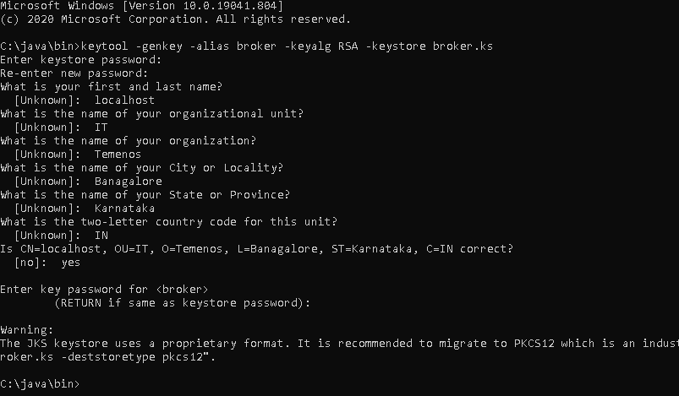

Step2: Export the broker’s certificate so it can be shared with clients:

keytool -export -alias broker -keystore broker.ks -file broker_cert

enter the password: password

Step3: Create a certificate/keystore for the client:

keytool -genkey -alias client -keyalg RSA -keystore client.ks

Once the preceding command is executed, enter the password for client
Password: password

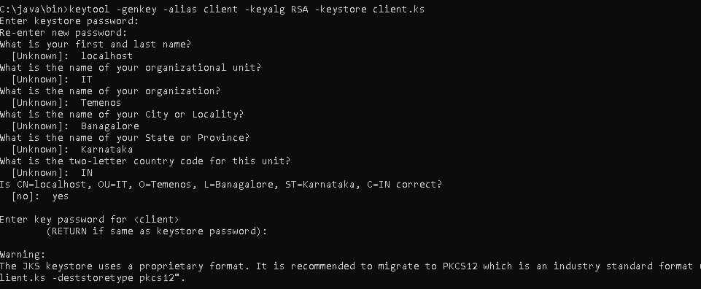

Step4: Create a truststore for the client, and import the broker’s certificate. This establishes that the client “trusts” the broker:

keytool -import -alias broker -keystore client.ts -file broker_cert

Password: password
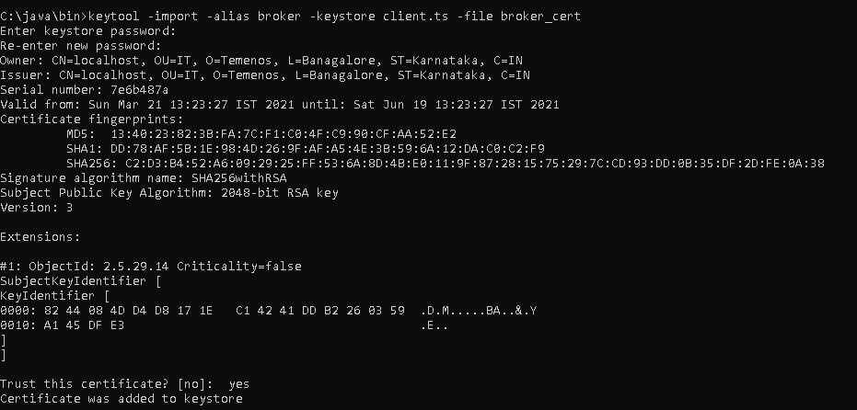
Step 5: Copy the files to activemq directory

Copy the generated keystore and certificate files from the installed Java/bin to activemq/conf (C:\apache-activemq-5.15.11-bin\apache-activemq-5.15.11\conf) directory.

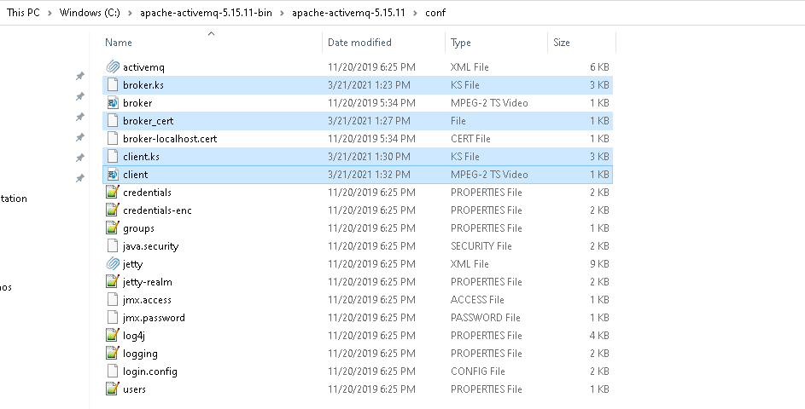
Step6: SSL Configuration in activemq.xml

Add the below SSL configuration in activemq.xml

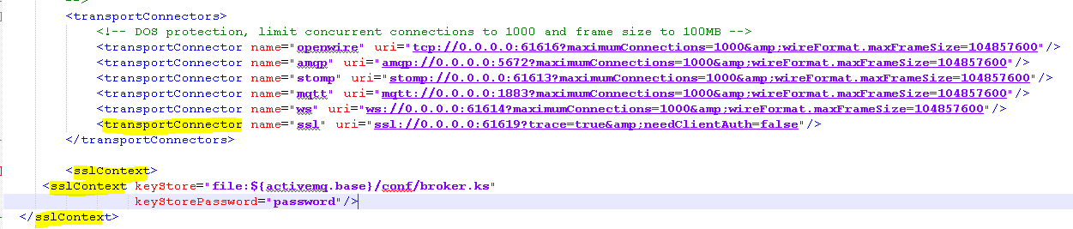



Step7: Start the Activemq
Start the Activemq from bin folder (C:\apache-activemq-5.15.11-bin\apache-activemq-5.15.11\bin)
Execute the command: activemq start
Connector ssl started (highlighted in yellow)

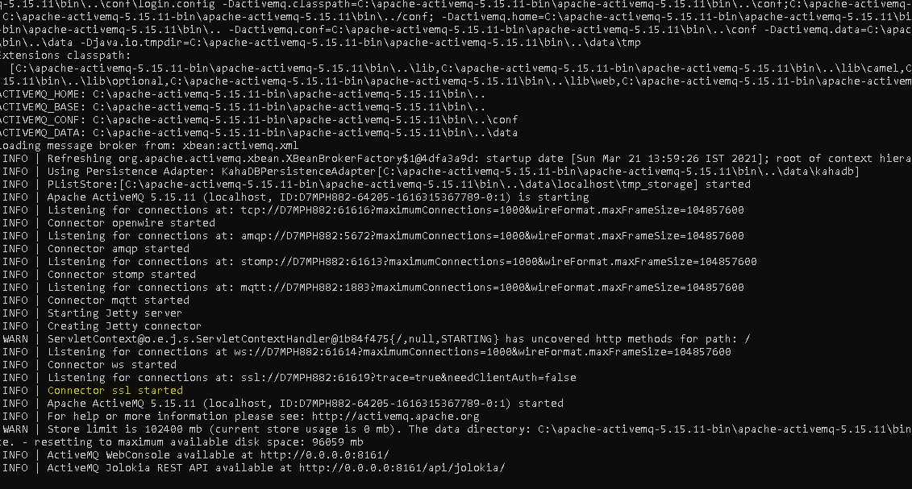
Step8: Connection Details

Configure application.properties for connecting to activemq as below

temn.tti.jms.config.file.name=activemq.xml
temn.tti.jms.security.password= admin

Configure activemq.xml for connecting to activemq as below

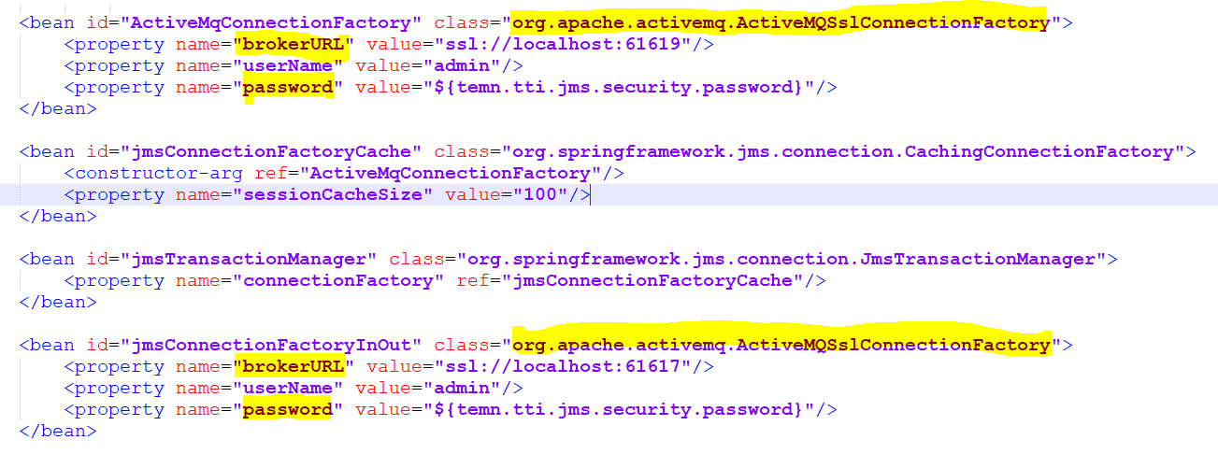

Step9: Start Camel Application

Give Truststore path and Truststore password as java arguments in start-tti.bat / start-tti.sh

-Djavax.net.ssl.trustStore=C:/apache-activemq-5.15.11-bin/apache-activemq-5.15.11/conf/client.ts
-Djavax.net.ssl.trustStorePassword=password

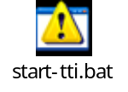

TTI camel will be started and you can verify the ssl connection in activemq console as below
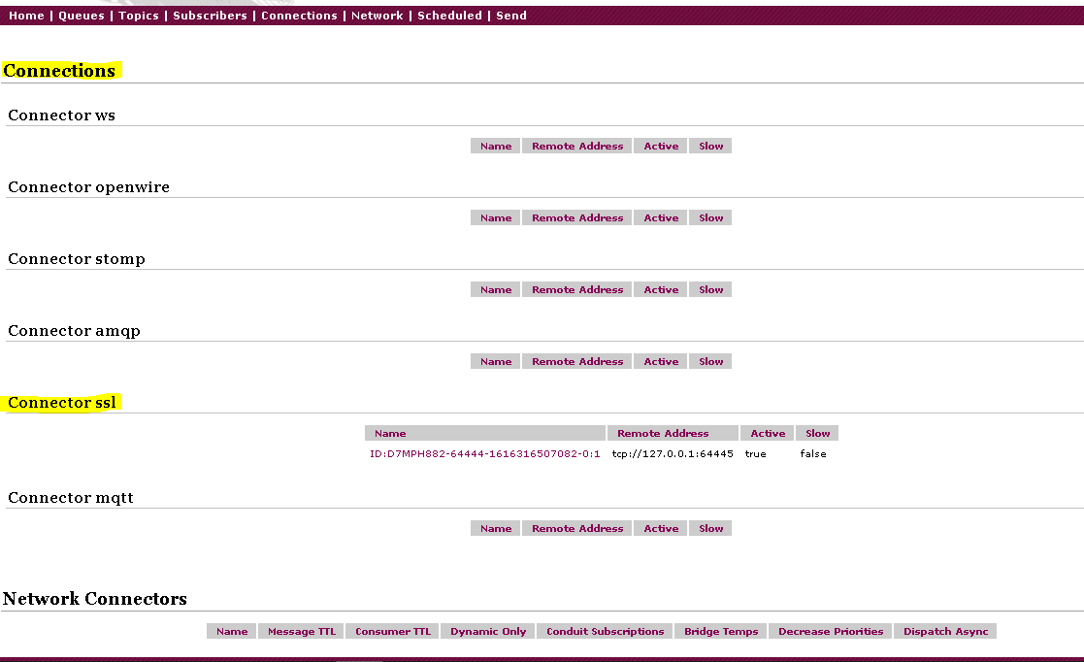

Jboss

Edit the Standalone-utp xml file as the below mentioned:

Step1:

<security-realm name="ApplicationRealm">
<server-identities>
<ssl>
<engine enabled-protocols="TLSv1.2"/>
<keystore path="application.keystore" relative-to="jboss.server.config.dir" keystore-password="password" alias="server" key-password="password" generate-self-signed-certificate-host="localhost"/>
</ssl>
</server-identities>
<authentication>
<local default-user="$local" allowed-users="*" skip-group-loading="true"/>
<properties path="application-users.properties" relative-to="jboss.server.config.dir"/>
</authentication>
<authorization>
<properties path="application-roles.properties" relative-to="jboss.server.config.dir"/>
</authorization>
</security-realm>

Step2:
<subsystem xmlns="urn:jboss:domain:remoting:4.0">
<http-connector name="http-remoting-connector" connector-ref="default" security-realm="ApplicationRealm"/>
<http-connector name="https-remoting-connector" connector-ref="https" security-realm="ApplicationRealm" sasl-protocol="remote"/>
<connector name="remoting-connector" socket-binding="remoting" />
</subsystem>

Step3:

<subsystem xmlns="urn:jboss:domain:undertow:7.0" default-server="default-server" default-virtual-host="default-host" default-servlet-container="default" default-security-domain="other">
<buffer-cache name="default"/>
<server name="default-server">
<http-listener name="default" socket-binding="http" max-parameters="10000" redirect-socket="https" enable-http2="true"/>
<https-listener name="https" enabled-protocols="TLSv1.2" security-realm="ApplicationRealm" socket-binding="https" enable-http2="true"/>
<host name="default-host" alias="localhost">
<location name="/" handler="welcome-content"/>
<http-invoker security-realm="ApplicationRealm"/>
</host>
</server>
<servlet-container name="default">
<jsp-config/>
<websockets/>
</servlet-container>
<handlers>
<file name="welcome-content" path="${jboss.home.dir}/welcome-content"/>
</handlers>
</subsystem>

Step4: (only for JMS)

<http-connector name="https-connector" socket-binding="https" endpoint="https-acceptor">
<param name="ssl-enabled" value="true"/>
</http-connector>
<http-acceptor name="https-acceptor" http-listener="https"/>

<connection-factory name="RemoteSSLConnectionFactory" entries="java:jboss/exported/jms/RemoteSSLConnectionFactory" connectors="https-connector"/>

The above four steps has been configured in below standalone-utp.xml for reference


Step 5: Generate keystore and certficiate

Java Keytool stores the keys and certificates in the keystore file. If you are a “Windows” user, the Keytool command should be executed in the Java bin directory.

Open cmd as admin.

cd C:\Open jdk11\bin

keytool -genkey -alias server -keyalg RSA -keysize 1024 -keystore application.keystore -validity 365 -keypass password -storepass password

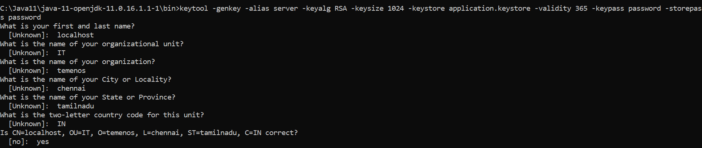

keytool -export -keystore application.keystore -alias server -file server.cer -keypass password -storepass password

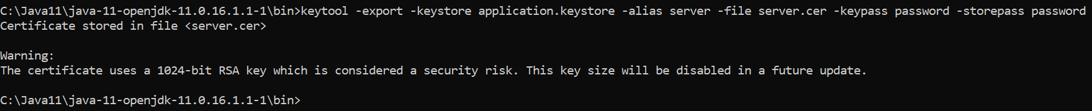

keytool -import -trustcacerts -alias server -file server.cer -keystore client.keystore -keypass password -storepass password

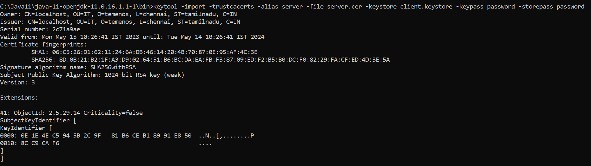

Step 6: copy files and change configuration in application.properties
Copy the application.keystore, client.keystore and server certificate to …/jboss/standalone/configuration folder

Configure application.properties for connecting to jboss as below

temn.tti.jms.config.file.name=jms_jndi.xml
temn.tti.jms.security.password= 123456

After doing the above configuration we need to change the jms_jndi.xml file. Change the provider url to connect to https port.

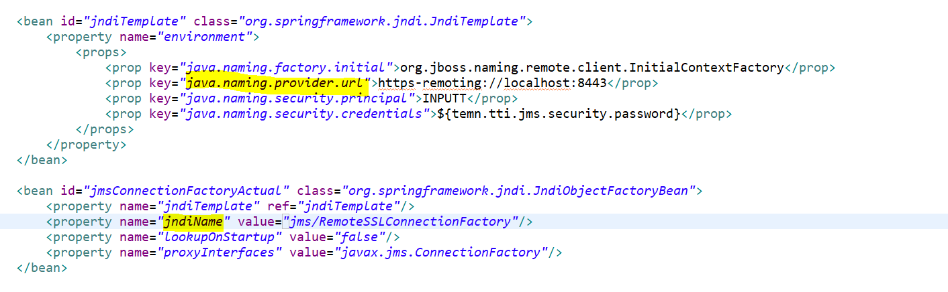

Enable SSL as true, Pass the truststore path and trust store password as Java arguments in start-tti file as below

-Djavax.net.ssl.trustStore=Z:\UTP-DEV-RET-2021.03.03-01-1062-saf-retailsuite-developer-s08\Temenos\jboss\standalone\configuration\application.keystore
-Djavax.net.ssl.trustStorePassword=password
-Djboss.naming.client.remote.connectionprovider.create.options.org.xnio.Options.SSL_ENABLED=true
-Djboss.naming.client.connect.options.org.xnio.Options.SSL_STARTTLS=true

IBM MQ

Open command prompt from the folder (Eg:- /oams/d_e2e_dev2/ssl) where you want to generate ssl certificates and run the following commands. “Ikeycmd” will be in your mq installation folder

Client

- CREATE CLIENT DATABASE
/opt/mqm/java/jre64/jre/bin/ikeycmd -keydb -create -db "client.jks" -pw clientpass -type jks

- CREATE CLIENT CERTIFICATE
/opt/mqm/java/jre64/jre/bin/ikeycmd -cert -create -db "client.jks" -pw clientpass -label ibmwebspheremqgwpmq -dn "CN=localhost,OU=gwpmq,O=mqm Company,C=SE" -expire 365

- CHECK THAT THE CERTIFICATE IS IN THE JKS
/opt/mqm/java/jre64/jre/bin/ikeycmd -cert -list -db "client.jks" -pw clientpass

Server

- CREATE SERVER DATABASE
/opt/mqm/java/jre64/jre/bin/ikeycmd -keydb -create -db "/var/mqm/qmgrs/MDO/ssl/MDO.kdb" -pw serverpass -type cms -expire 1000 -stash
- “/var/mqm/qmgrs/MDO/ssl”. This is the path of the queuemanager.Change to proper location

- CREATE SERVER CERTIFICATE
/opt/mqm/java/jre64/jre/bin/ikeycmd -cert -create -db "/var/mqm/qmgrs/MDO/ssl/MDO.kdb" -pw serverpass -label ibmwebspheremqmdo -dn "CN=MDO,OU=ICC,O=GU,C=SE" -expire 1000 -sig_alg SHA256_WITH_RSA

- CHECK THAT THE CERTIFICATE IS IN THE KDB
/opt/mqm/java/jre64/jre/bin/ikeycmd -cert -list -db "/var/mqm/qmgrs/MDO/ssl/MDO.kdb" -pw serverpass

Extraction

- EXTRACT THE PUBLIC PART OF THE CLIENT CERTIFICATE
/opt/mqm/java/jre64/jre/bin/ikeycmd -cert -extract -db "client.jks" -pw clientpass -label ibmwebspheremqgwpmq -target client.crt -format ascii

- ADD THE CLIENT CERTIFICATE TO THE SERVER
/opt/mqm/java/jre64/jre/bin/ikeycmd -cert -add -db "/var/mqm/qmgrs/MDO/ssl/MDO.kdb" -pw serverpass -label ibmwebspheremqgwpmq -file client.crt -format ascii

- CHECK WHETHER BOTH CERTIFICATES ARE IN THE KDB
/opt/mqm/java/jre64/jre/bin/ikeycmd -cert -list -db "/var/mqm/qmgrs/MDO/ssl/MDO.kdb" -pw serverpass

- EXTRACT THE PUBLIC PART OF THE SERVER CERTIFICATE
/opt/mqm/java/jre64/jre/bin/ikeycmd -cert -extract -db "/var/mqm/qmgrs/MDO/ssl/MDO.kdb" -pw serverpass -label ibmwebspheremqmdo -target MDO.crt -format ascii

- ADD THE SERVER CERTIFICATE TO THE CLIENT JKS
/opt/mqm/java/jre64/jre/bin/ikeycmd -cert -add -db "client.jks" -pw clientpass -label ibmwebspheremqmdo -file MDO.crt -format ascii

- CHECK WHETHER BOTH CERTIFICATES ARE IN THE JKS
/opt/mqm/java/jre64/jre/bin/ikeycmd -cert -list -db "client.jks" -pw clientpass

Queue Manager Changes

Go to IBM MQ installation folder and run the following commands. cd /opt/mqm/bin
- runmqsc (your Queue manager Name)
- ALTER QMGR SSLKEYR('/var/mqm/qmgrs/MDO/ssl/MDO')
  - Mention path of your SSL keys in the above cmd
- ALTER QMGR SSLFIPS(NO)
- DEFINE CHANNEL('CLIENTS') CHLTYPE(SVRCONN) TRPTYPE(TCP) SSLCIPH(TLS_RSA_WITH_AES_128_CBC_SHA256) MCAUSER(gwpmq) SSLCAUTH(REQUIRED) REPLACE
- ALTER QMGR CHLAUTH (DISABLED)
- REFRESH SECURITY TYPE(SSL)

Config changes

Add the following property in ibmmq.xml. This property indicates the Cipher Suite which is configured in the above steps. Add it under mqcredential bean id.

- <property name="sSLCipherSuite" value="TLS_RSA_WITH_AES_128_CBC_SHA256" />

Script changes

Add the following arguments in the start-tti.sh script file and start tti.

- -Dcom.ibm.mq.cfg.useIBMCipherMappings=false
- -Djavax.net.ssl.trustStore=/oams/d_e2e_dev2/ssl/client.jks
  - “/oams/d_e2e_dev2/ssl” is the location of key. Change to proper location
- -Djavax.net.ssl.trustStorePassword=clientpass
- -Djavax.net.ssl.keyStore=/oams/d_e2e_dev2/ssl/client.jks
  - “/oams/d_e2e_dev2/ssl” is the location of key. Change to proper location
- -Djavax.net.ssl.keyStorePassword=clientpass

Sample Files

- PFB Sample file.

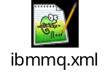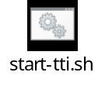

Containerization

Camel DockerFile available in this location tti-camel-*.*.*\docker
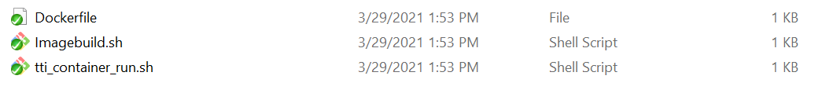
Before to build TTI camel Image, please make sure the below are available.
- Docker service up and running
- You should have an existing image Open jdk11 pulled from Docker repository
- Copy the XSLT and config folder which will be available in TTI distribution under IB folder into Docker folder where the docker file is available.
- Execute the Imagebuild.sh( to create the image
- Execute tti_container_run.sh to start the container

